MUSIC DEPARTMENT HANDBOOK

For

**GROTON JR. - SR. HIGH SCHOOL**

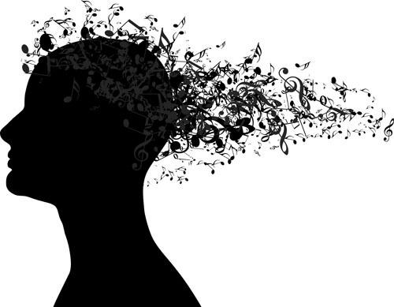

Ms. Skyler Roswell, Instrumental Director

Ms. Laura White, Choral Director

Welcome!

Dear students and families,

It is our pleasure to welcome you to the Groton Jr/Sr High School’s music family! We are pleased that you have chosen to be a part of this music group. Groton has a long tradition of excellence in music and we hope you are ready to work hard to continue this tradition!

The following handbook has been created so that you and your parent(s)/guardian(s) can become familiar with the expectations, goals, and policies of this program. We encourage the families of our students to play an active role in the musical journey that their children have begun by



joining the Groton music family.



Please take time to read through the materials **together.**

After you finish reading the material, please sign and return the “Acknowledgement Form” at the end of the handbook.



This form is to be returned no later than

**Friday, September 14th, 2018.**

You are part of a musical team! We count on you to maintain a positive attitude and a high level of dedication. All we can ask of you is that **do your personal best!**

Let’s have a great year!

**Table of contents:**

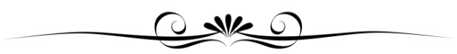

Page 2: Welcome

Page 3: Class Descriptions

Page 4: Grading Policy

Page 5: Concert Information

Page 6: Expectations & Contacts

Page 7: NYSSMA & Updates

Page 8: Family Involvement & Remind

Page 9: Music Dept. Calendar

Page 10: Acknowledgment Form

**Meet Our Staff**

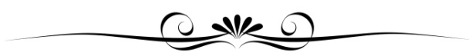

|  |  |
| --- | --- |
| Principal | Billie Downs |
| Associate Principal | Jake Roe |
| Dean of Students | Mark Triolo |
| Instrumental Director | Skyler Roswell |
| Choral Director | Laura White |

-Ms. Skyler Roswell and Ms. Laura White

**As a Music Director, I am committed to:**



* Providing a safe place for students to grow musically
* Helping students develop a feeling of musical competency
* Fostering students’ love of music and appreciation for fellow musicians and artists
* Helping students begin to establish their place in the global community of music
* Providing outlets for creativity and self-expression
* Exposing students to a broad range of musical styles
* Providing an atmosphere in which all students may participate as musical performers
* Fostering leadership skills in each student
* Developing in each individual the habits of responsibility and preparation in an atmosphere of cooperation and teamwork
* Enabling students to gain knowledge, understanding, and skills that will allow them to succeed in other areas of their lives
* Encouraging students to give back to the community though music
* Cultivating meaningful partnerships among students, teachers, families, and community members

 **Instrumental Class Descriptions** 

|  |  |  |
| --- | --- | --- |
| **Lessons**  **Image result for music symbols as page break** | **Band Rehearsals**  Image result for music symbols as page break | **Cadet Band**  Image result for music symbols as page break |
| As a member of the instrumental program, students will receive a **weekly, 40-minute, small-group lesson**. Lessons are scheduled during the school day and are coordinated with classroom teachers. Students are expected to attend all lessons and band rehearsals. The music lesson is the core of the instrumental program and the time in which students acquire the fundamental skills necessary for musical success and development.  Lessons are “pull –out” classes, meaning that students leave their regular classroom during the day in order to attend. Ms. Roswell and the classroom teachers work together to make this a successful experience for students, but **ultimately the student is responsible for any work that is missed. I expect all band students to be good students,** and I will stay after school as often as I can to help them with Math, English, or any other subject they need. | The rehearsal is part of the master schedule and provides an opportunity for students to implement the skills acquired during lessons. During this time, students further learn the value of teamwork, cooperation, and responsibility.  **Practice Vs. Rehearsals**  Image result for music symbols as page break  It is important to practice the sections of music that will be rehearsed so we can spend time making music, not fixing the problems created by a lack of preparation. Know the time (pulse/beats), rhythms, and fingerings before we start playing! Remember that rehearsal is the task of turning many ideas into one idea. In other words, we need to work as a team to put parts together to create a thrilling performance experience! If you did not practice, you are only hurting the band’s potential to sound better!  **Jazz and Pep Band**  **Image result for music symbols as page break**  These two extracurricular groups are more advanced players and done through an invite or audition basis. | This is a beginning to intermediate level group for students new to playing their instrument (0-2 yrs). This group will prepare and perform levels .5 to I music. Lessons will start the week of September 17th and continue throughout the school year until June.  **Symphonic Band**  **Image result for music symbols as page break**  This more experienced group is for students who have already participated in Cadet band. This group will prepare and perform I-IIII music. Lessons will start the week of September 17th and continue through the school year until June.  **Wind Ensemble**  **Image result for music symbols as page break**  Wind Ensemble is an elite group for SH students that will be challenged with levels III-V music. Lessons will start the week of September 17th and continue through the school year until June.  Image result for clip art band rehearsal |

**Rental Information**



Students participating in the instrumental program at Groton are expected to rent their instrument directly from

a local music store retailer. Arrangements should be made with a vendor of choice at your earliest convenience to ensure availability. Further, students and parents will be responsible for transporting their instrument to and from the weekly lesson and rehearsal.

**Please contact the teacher immediately if there is a financial issue**. In such cases, school instruments will be availableuntil supplies last. Before a student will be allo wed to take a school-owned instrument home, the student and his or her parent or guardian must sign a loan agreement acknowledging that they take full responsibility for the instrument. All students are expected to provide their own accessories, such as mouthpieces, reeds, oils, etc.

A student who owns or is renting his/her own instrument should assume the same responsibility and precaution as one with a school owned instrument. **No student should use anyone else's instrument except when given** **permission by the director. This includes non-percussionists using percussion instruments.** Be sure to have a writtenrecord at home of the make, serial number, and finish of your instrument, because this information is necessary should it be lost or stolen.

**Materials Needed:**

Having the right equipment can make a big difference in the success or failure of a music student! Without good reeds, oil, or sticks a student cannot play up to his/her potential. Protect your investment. The following is a list of all **REQUIRED** accessories (as well as some optional ones) that the student will need for their instrument. All students must also have a folder with pockets and *at least* 2 pencils.

Valve oil Cork Grease Reed guard Drumsticks Method book Metronome

Slide grease Size 3 Reeds Music stand Practice pad Tuner

 **Choral Class Descriptions** 

|  |  |  |
| --- | --- | --- |
| **Lessons**  **Image result for music symbols as page break** | **7/8th Grade Chorus**  **Image result for music symbols as page break** | **Chamber Choir**  Image result for music symbols as page break |
| All students enrolled in a Chorus class are also enrolled in Voice Lessons, which occur once every 6- day cycle for SH and once monthly for JH. There will be 2-5 students in each voice lesson group and each group’s lesson time will rotate through multiple periods so they do not miss the same class every time. In these lessons, students develop their sight-singing and music theory skills while learning solo pieces. They will perform these solo pieces as assessments each semester for their lesson group and may use the pieces to audition for NYSSMA.  **6th Grade Chorus**  **Image result for music symbols as page break**  This group is open to anyone in the 6th grade who wants to sing! We will rehearse and perform high quality choral literature from various styles and time periods, focusing on ensemble building, vocal confidence, and music reading. Students will rotate voice parts throughout the year. Every student will attend monthly voice lessons to track vocal progress and voice change. There are 3 main concerts per year. | This group is open to anyone in the 7th or 8th grade who wants to sing! Experience in the 6th grade choir is encouraged but not required. A larger ensemble allows us to perform more challenging repertoire from various styles and time periods. We will focus on ensemble building, vocal development, and music reading. Students will rotate voice parts throughout the year. Every student will attend monthly voice lessons to track vocal progress and voice change. There are 3 main concerts per year.  **SH Chorus**  **Image result for music symbols as page break**  This group is open to any senior high student who wants to sing! Experience in 7th/8th grade choir is  encouraged but not required. With this group we will perform high quality repertoire from numerous styles, time periods, and cultures. In class, we will sight-read daily to improve musicianship. We will focus on ensemble building, vocal technique, expression, and music reading. Every student will attend one voice lesson per 6 day rotation (see Voice Lessons). **This year, students must attend at least 6 lessons per quarter**. There are at least 3 concerts per year. | This year we are forming a small select ensemble of dedicated 10-12th grade choir members that will study very challenging music. We will focus on tone, music reading, and small ensemble building. We will rehearse during the school day on a flexible schedule and before school when necessary from 7:15-7:55am.  **Glee**  **Image result for music symbols as page break**  Now in its second year, Glee is an after-school choir open to anyone in grades 6-12, no audition required. You do not have to be in choir during school to join, but it is a commitment just like a sport or club. We will perform repertoire at the same concerts as the in-school choirs, and also will participate in FUNdraisers such as caroling and Valentine’s Day singing telegrams. Bring your friends! |

**Ensemble Grading Policy**

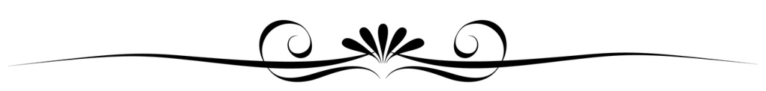

Students will receive a grade in band/instrumental lessons and in choir/voice lessons on their report cards.

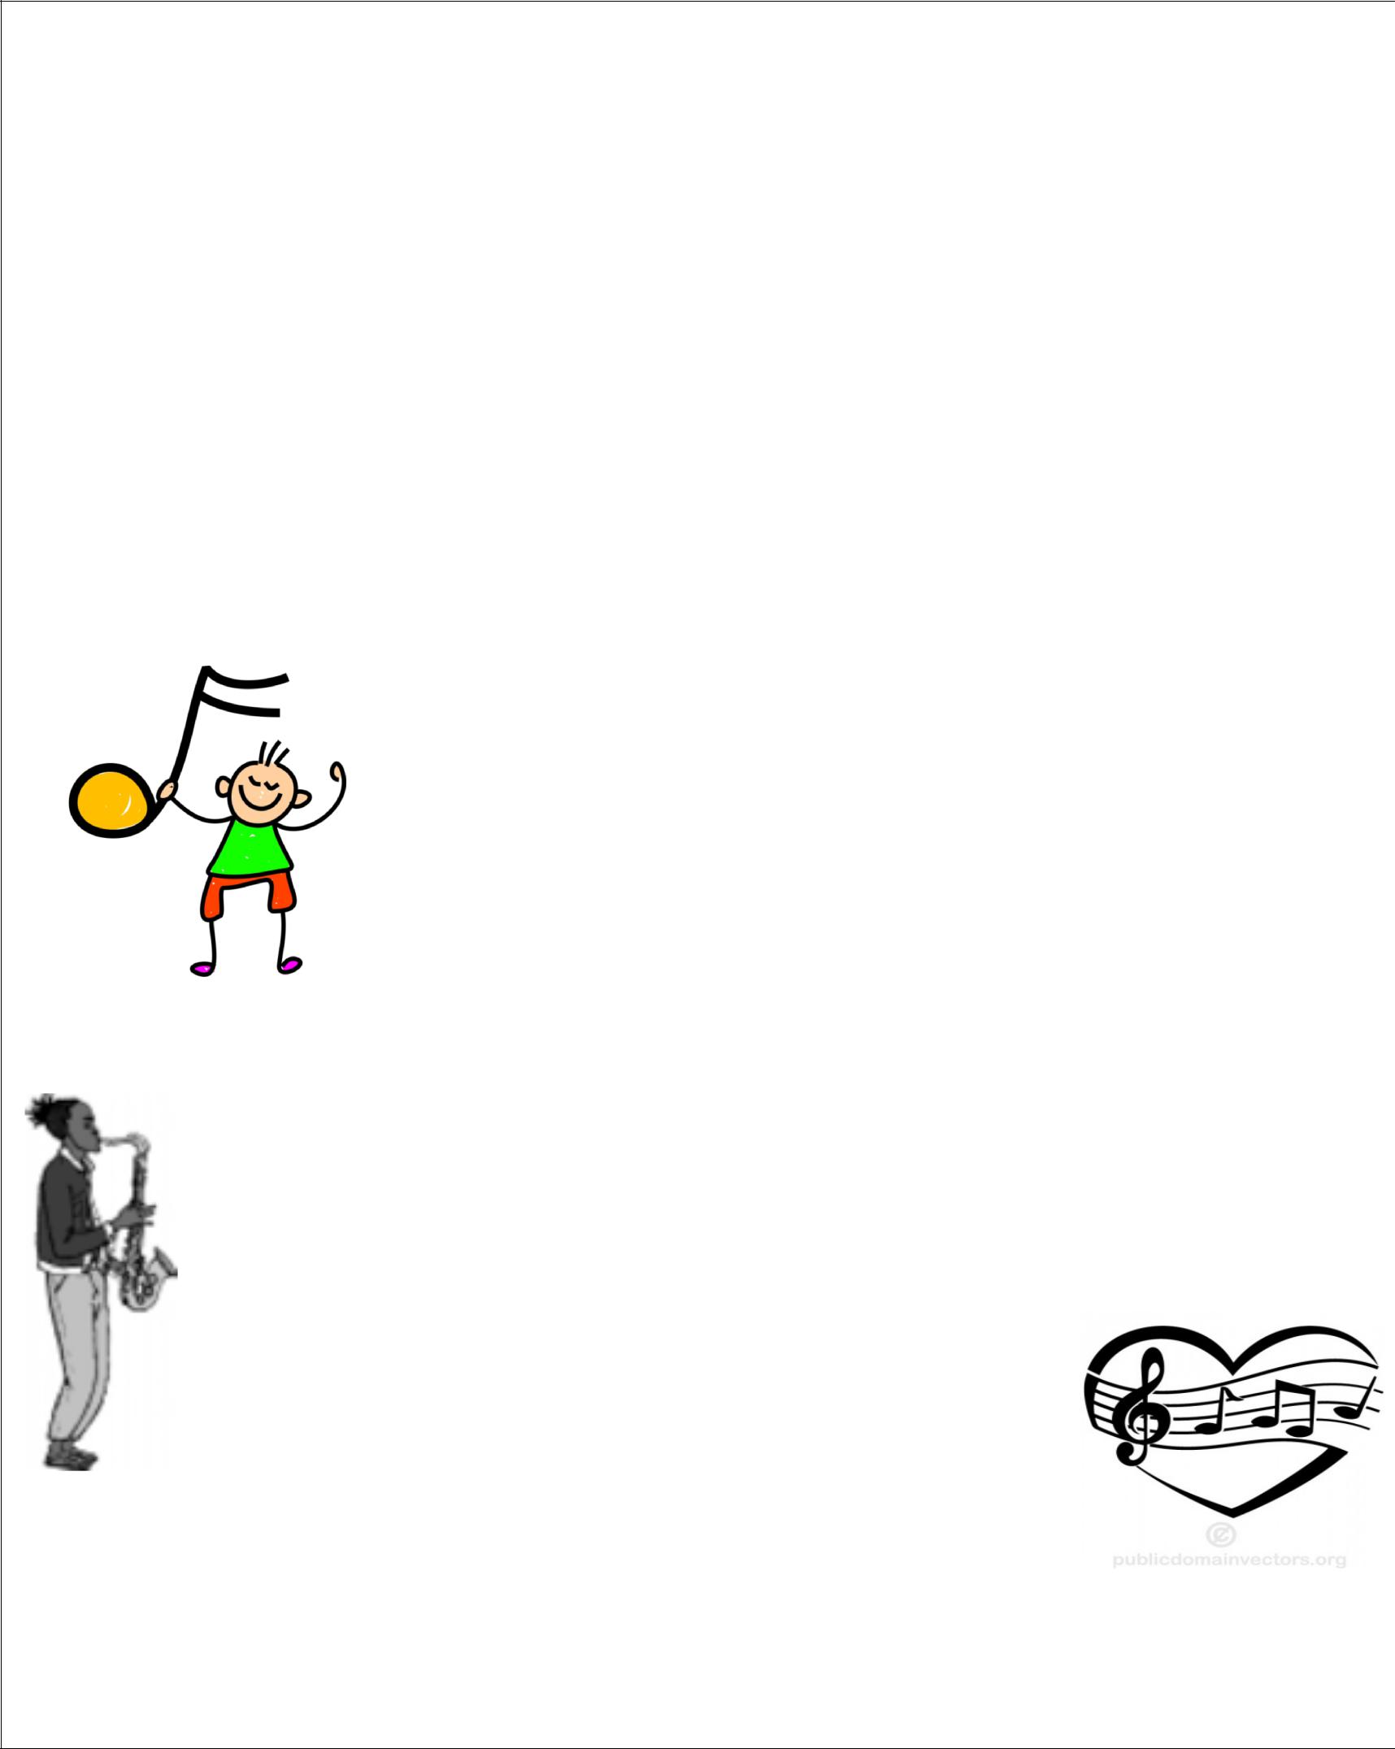Rubrics and enrichment activities will be sent home or emailed in “Music Notes” Newsletters.

The grading rubric is as follows:

25% Rehearsal Participation

25% Concert and Solo Performances

20 % Lessons

20% Projects and Assignments

10 % Sight-Reading

Student Awards/Recognition

Ms. Roswell and Ms. White will appoint leaders and officers.

 Special awards are presented annually at the Music Awards Banquet to individual students who distinguish themselves through hard work, dedication, positive attitude, leadership, high marks, progress and musicianship.

**Concerts**



Instrumental and choral students will participate **in three or more concerts** during the school year. Performances give students opportunities to showcase their hard-earned musical skills and give back to the community with their talents. Therefore, **attendance at concerts is** **MANDATORY** for all members of the Groton Bands and Choruses. The contribution of every child is vital to the success of developing team‐oriented ensemble skills. Please help teach your young musicians the importance of honoring commitments and please put these dates on your calendar as soon as possible.

**Save The Dates:**

**Beginner Band Concert**: Wednesday, November 14th, 6:00pm

**Winter Concert**: JH - Thursday, December 6th

SH - Thursday, December 13th

**\*Music in Our Schools Concert\***: Band- Wednesday, March 27th

Chorus- Thursday, March 28th

**Spring Concert**: JH- Thursday, May 16th

SH- Wednesday, May 22nd

**All concerts are at 7:00 p.m. in the Groton High School Auditorium.**

**Please see the music dept. calendar on the last page for all important dates!**

*\*Please note: This year the March concert is split by band/chorus, not JH/SH.*\*

|  |  |
| --- | --- |
| **What to Wear** | |
| **Black** dress shirt or Blouse  Necktie  Black dress shoes (heels < 2")  Black socks or Tights  Black dress pants or Skirt  (BELOW the knee!) | Concerts are formal presentations and we expect students to dress accordingly.  We have extra attire for those that need it; simply ask. We will also give students this extra attire if they arrive wearing inappropriate clothing (short skirt, words on the shirt, etc.). |

**Concert Policy**

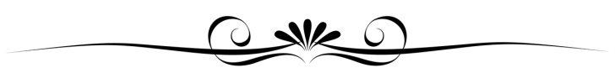

|  |  |
| --- | --- |
| **Excused Absences Include** | **Unexcused Absences Include** |
| 1) Severe Illness (absent from school)  2) Family Emergency(funeral, unexpected hospital trip)  3) Car accident (en route to concert)  We hope these never occur! | Sports practice/games, Dance recitals, Family vacation/event, Too much homework, Lack of transportation, Forgot about it, etc. |

**You Have a Choice!**

If the student would like an absence to be excused due to illness, they must provide a **signed note** from a parent/guardian at least 24 hours prior to the performance. In case of an unexpected emergency, the parent/guardian should **text us immediately** if possible and **bring a signed note the *next time* we see each other.**

After confirming an excused absence, the student will **complete an alternative performance** assignment for credit. The **student will be responsible** for scheduling the meeting with us in which the student will perform their part of the concert pieces.

**Absences will automatically result in a 0** for the performance but can be made up upon completion of this process. A signed note for a reason falling under the ‘unexcused’ absences does not excuse the student from the concert and they will receive a zero. If you have any questions about this process please contact us in advance.

Concerts are scheduled a year in advance and dates are made available the first week of school. Please see the music dept. calendar on the last page of this handbook for all important dates. Events marked "Required- Y" are mandatory for the RELEVANT students; for instance, SH students are required to attend the SH concert.

**Please mark your calendars now!**



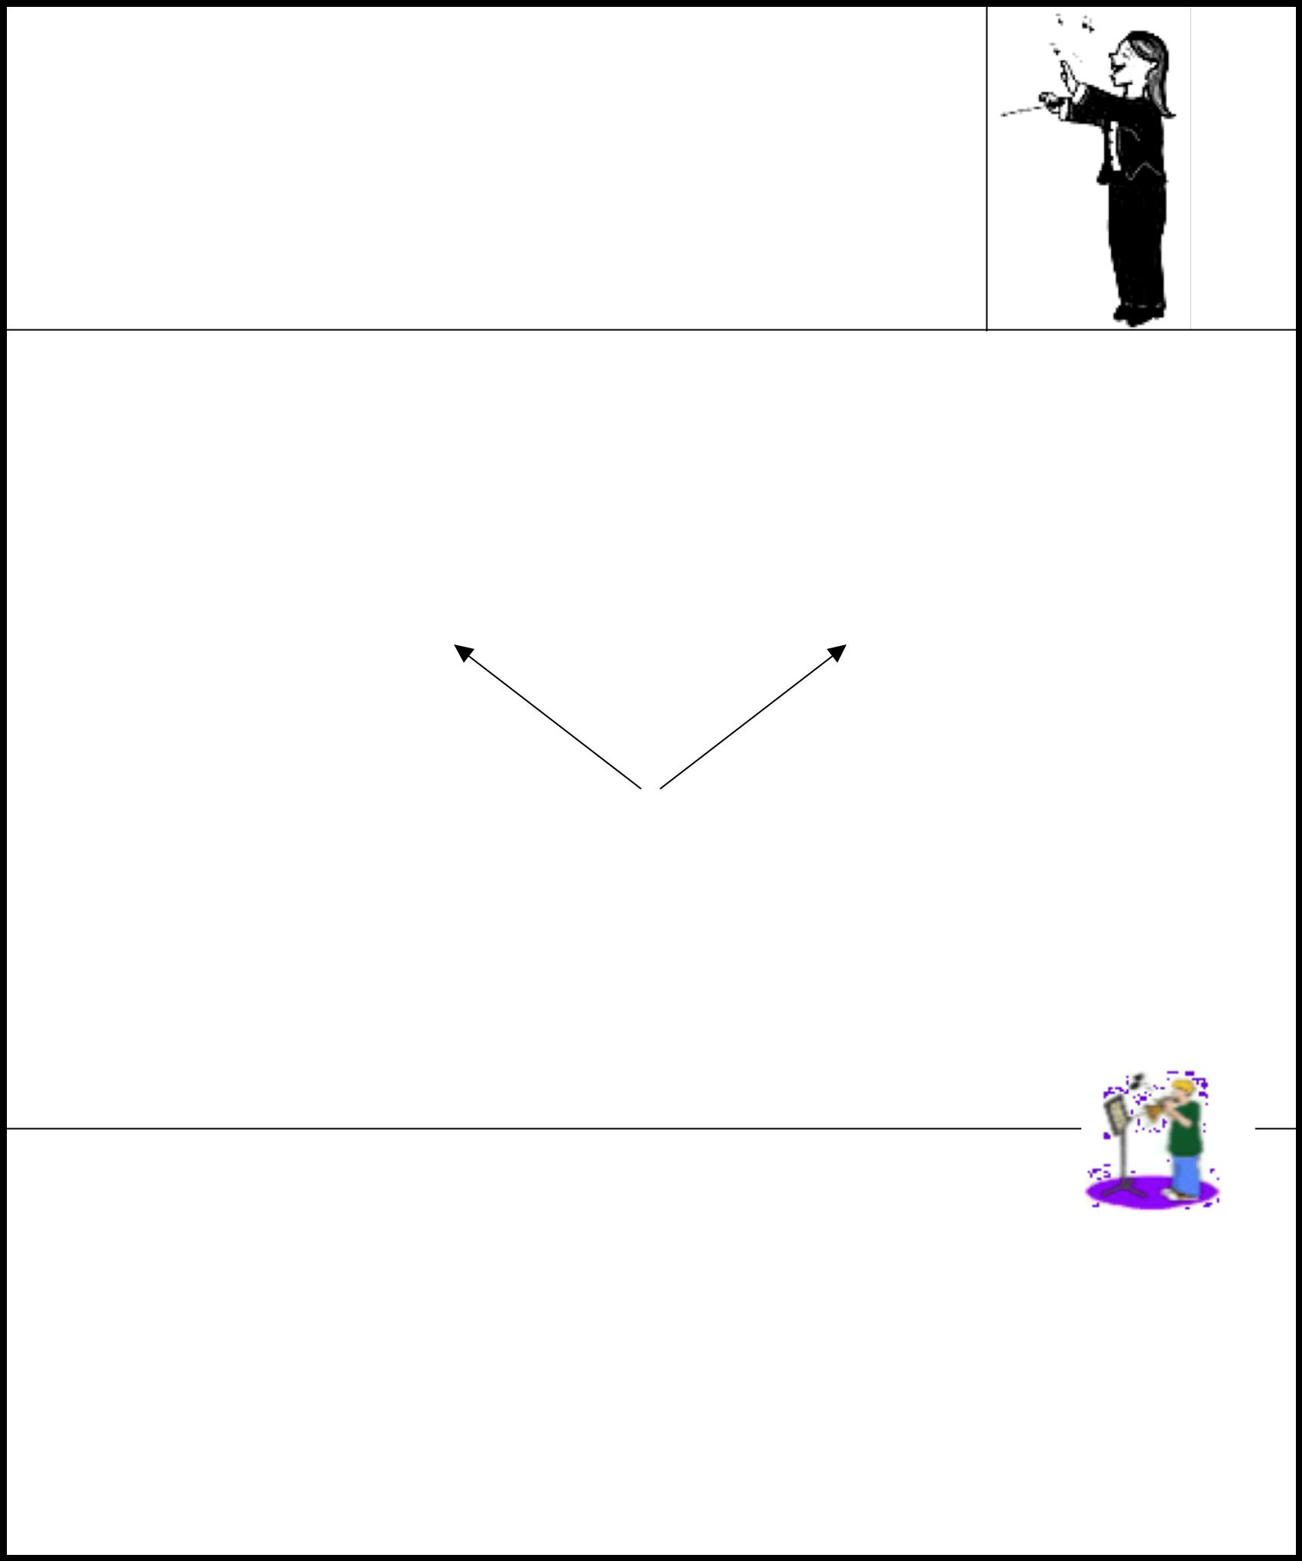**What you can expect from your teacher:**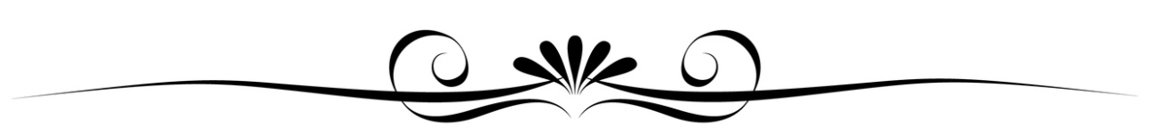

***The following is my promise to you, my students***.

* I pledge to show you the joys of making music and to teach you to be a musician.

Work hard, and our time together will be fun.

* I will expect and encourage you to do your best. My goal is for you to become an excellent musician.
* I will listen. If you have something important to say, we can talk about it.
* I will teach by example. Do what I do, not just what I say.
* I will try to explain things clearly. If you ever don't understand something, just ask and I will explain it more carefully.

**What I will expect from you**

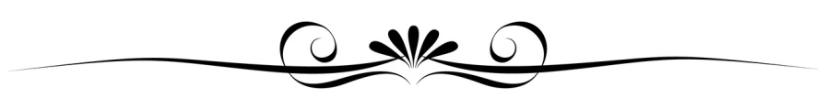

|  |  |
| --- | --- |
| **4 Pillars for Success** | **Consequences** |
| Mutual Respect  Attentive Listening  Kindness  Best Effort | Ask (Verbal Warning) Tell (2nd warning and correction)  Refer (CTC, Call home, office referral as needed) |

**Student**

**YOU HAVE A CHOICE!**

You are an important member of our team, and your actions will affect everyone else in our group. Your behavior will determine how much we learn and how well we play/sing, and will also show the community what Groton is all about. ***When you choose your actions, always remember that you are choosing your consequences as well.*** When you do your best and become energized with music, it all adds up to making excitement! However, poor behavior can ruin the good impression of our group and even worse, it can make learning music more difficult and less fun.

**Practice makes ~~perfect~~ PERMANENT**

 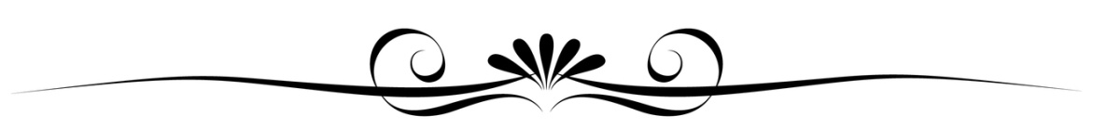

* Practice your lesson and ensemble materials regularly **at** ***least*** 5 times per week:
* 6th grade students: 10-15 minutes a day x5 = (60 -75 minutes each week)
* 7th grade students: 15–20 minutes a day x5 = (75 – 100 minutes each week)
* 8th grade students: 25-30 minutes a day x5 = (100-150 minutes each week)
* 9th-12th grade students 30 - 40 minutes a day x5 (150 - 200 minutes each week)
* Your practice time does not include lessons and rehearsals
* **All students**: Your practice sessions will be filled out accordingly and signed by a parent/guardian andreturned each week.
  + Be willing to keep working hard even when things get a little frustrating, so that you can keep improving.
  + Take initiative to teach yourself and improve as much as you can on your o wn.
  + Let me know if you are confused or frustrated about anything or have any questions.
  + Take good care of your instrument. Keep it clean and well oiled.
* •Enjoy yourself. Playing music is very satisfying and you will learn more when you are enjoying your playing.

**CONTACT US**

**Skyler Roswell:**

Sroswell@groton.cnyric.org

607-898-5802 ext. 2208

**Laura White:**

Lwhite@groton.cnyric.org

607-898-5802 ext. 2207

** NYSSMA**



**What is NYSSMA?**

The New York State School Music Association is the NY affiliate of NAfME (National Assoc. for Music Education). It is a professional organization that evaluates student musicians in our state from elementary to high school. They host festivals at which students perform solo pieces and are evaluated by a judge; some festivals evaluate full ensembles as well.

Students may perform simply to be evaluated, or they may audition for honor ensembles that occur throughout the year. These honor ensembles include, in an increasing level of selectiveness:

All-County

Area All-State

Conference All-State

All-Eastern

If selected, students will rehearse repertoire for the select ensembles and attend a 2-3 day festival culminating in a final concert. These ensembles are led by renowned conductors and educators from across NY and the country.

**Who can participate?**

Any Groton student who is enrolled in Band and/or Choir may participate! In some cases, there are limits to the number of students who may audition, in which case students will audition for us first. The most prepared and skilled students will then be able to audition for NYSSMA.

**Why should I participate?**

The solo evaluations and auditions will help you grow as a musician. These performances will help you overcome performance anxiety while providing you with useful feedback. You can use this feedback to improve your musicianship. If selected for an honor ensemble, you will study under incredible educators and perform with passionate musicians such as yourself, inspiring you to continue making music.

**How can I audition?**

Auditions for honor ensembles occur each spring for the following school year (to participate as a senior, you audition as a junior). To sign up, you must indicate your interest to your teacher and sign a permission form.

Senior High students should study their audition piece during their weekly lessons to prepare. Junior High students should meet with their teacher during a study hall or after school to select and prepare an audition piece.

**When/where are the NYSSMA solo Festivals?**

April 6th- Cortland

May 3rd and 4th- Boynton MS, Ithaca

Depending on the number of students, we will either take a bus together or arrange carpools.

**When/where are concerts and conferences?**

Please visit our Music Department website for dates/locations of the concerts and performances. They occur throughout the school year. Anyone is welcome to attend, whether or not their student is performing! All-County performances are free, though all others are ticketed events.

**KEEP IN TOUCH!**

|  |  |
| --- | --- |
| **Bookmark Us!** | **Remind** |
| Please stay up to date and check the website regularly! We will include calendars, lesson schedules, rehearsal tracks, pictures and videos, resources, teacher bios, and so much more!  **www.grotonmusic.weebly.com** | Please join Remind to receive band/chorus updates. This service allows us to text you briefly through a school-approved service. We will treat Remind like email, contacting you with important information about concerts/events and the occasional shout out.  **See page 8 for sign-up information.** |

**Partnering with Families**

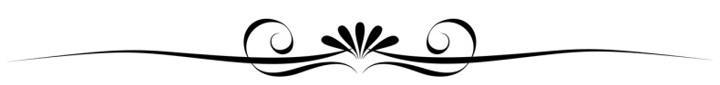

Groton Visual Performing Arts Boosters is a devoted group of parents and staff who have volunteered their time to build a Booster Club for the Arts at Groton Junior and Senior High School. This group’s members have applied their particular talents as musicians, writers, designers, speakers and organizers - to fundraise and to raise awareness. They do so in order to achieve our goals and supply the various groups with things they are not able to provide themselves. They meet a few times throughout the year. If you would like to donate or join our team, please contact us. We would love to have you!

**First Meeting: Sept. 19th at the Groton High School**

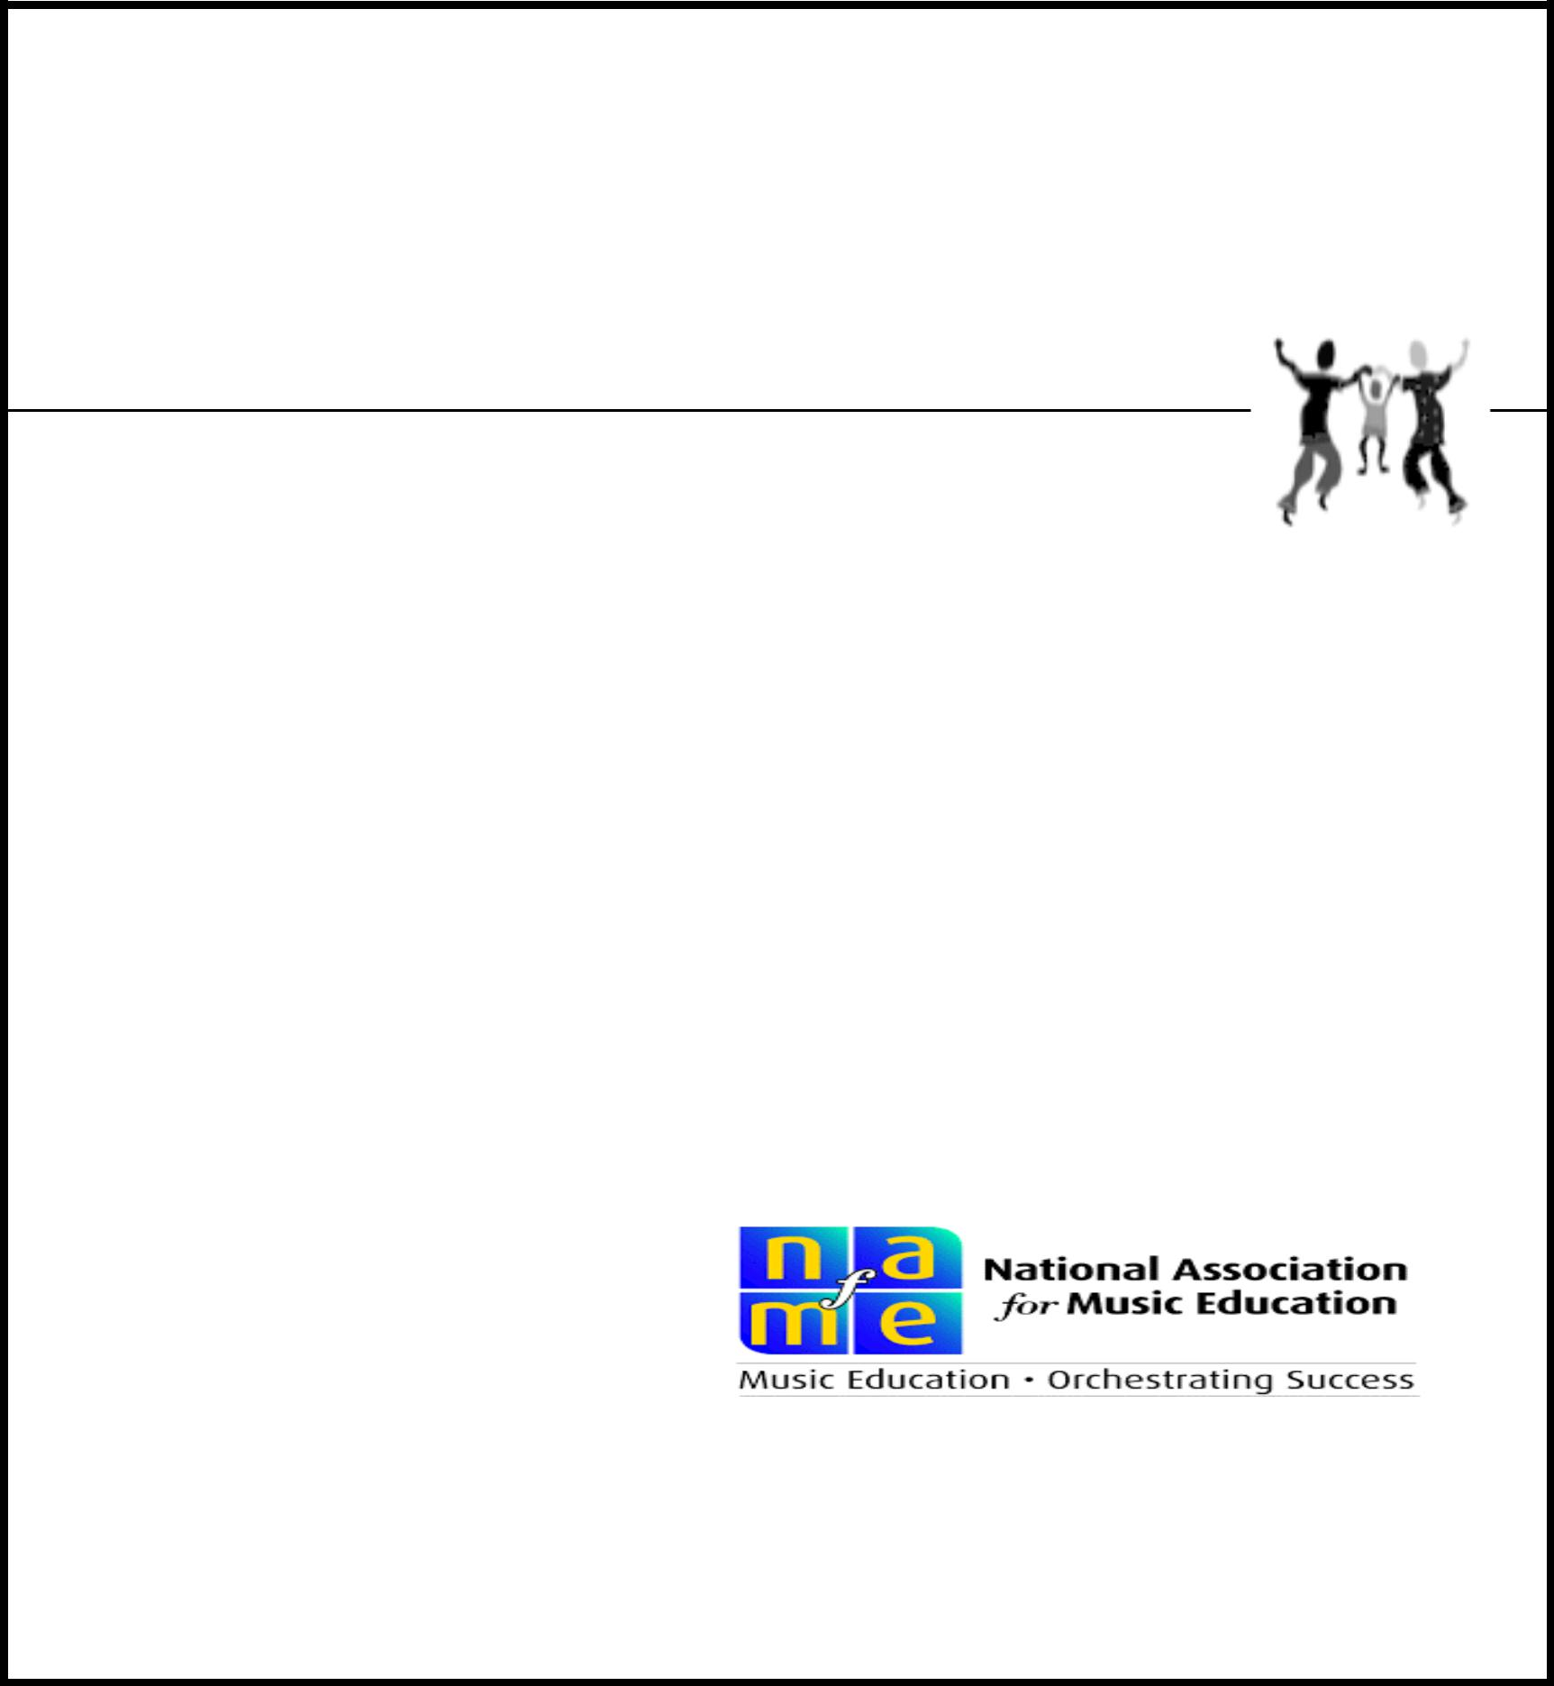**How YOU can help**



* Encourage your musicians to practice, practice, practice!
* Attend the concerts to see your musicians perform!
* Attend concerts with your musicians besides their own!
* Encourage your musicians to participate in NYSSMA!

**Why learn to play music?**



* Learning to play a musical instrument helps students build confidence. They take pride in their achievements, both individual and as members of an ensemble.
* Students who participate in music education programs see music as their “social glue,” connecting them to one another and the wider world.
* On average, music students score higher on both the verbal and math portions of the SAT, helping them to get into good colleges and universities.
* Students who take music classes tend to have fewer drug and alcohol problems and fewer brushes with the law.
* Music education helps in the development of 21st-century skills that employers prize, including:

1. Critical thinking and problem solving

o Collaboration

o Creativity

o Initiative and self-direction

1. Leadership and responsibility

For today’s students to succeed tomorrow, they need a comprehensive education that

Includes music education provided by exemplary music educators.

© National Association for Music Education ( w w w .nafme.org)

**HOW TO JOIN REMIND**



**JH Chorus:**

Text @bkhc8 to the phone number 81010

**SH Chorus:**

Text @h4ef63 to the phone number 81010

**Glee:**

Text @46848a to the phone number 81010

**Chamber Choir:**

Text @bc9eb2 to the phone number 81010

**Tri-M:**

Text @223kg8 to the phone number 81010

**Wind Ensemble:**

Text @msroswe to the phone number 81010

**JH Band:**

Text @e3c7c9 to the phone number 81010

**Jazz Band:**

Text @msroswel to the phone number 81010

**MUSIC DEPARTMENT CALENDAR 2018-2019**

|  |  |  |  |  |  |  |
| --- | --- | --- | --- | --- | --- | --- |
| **Date** | **Time** | **Event** | **Grades** | **Location** | **Required?** | **Chaperone Needed** |
| September TBA |  | Open House | 6-12 | High School | N | N |
| October TBA | 5-7pm | Music Night | 4-12 | High School | N | N |
| October |  | All County Rehearsals Begin | 6-8 | High School | Y- AC Band | Roswell |
| October TBA | Daytime | Field Trip to Elementary | 9-12 | Elementary | Y | N |
| October 15 | 4-6pm | All County Reading - JH BAND | 6-8 | Dryden | Y- JH AC | Roswell |
| October 27 | 5-8pm | Haunted Hallow | 7-12 | High School | N | Y- 3 |
| October TBA | 8-10pm | Ithaca College Concerts | 6-12 | Ithaca College | N | White/Roswell |
| November 2-3 |  | JH Area All State | 6-8 | Ithaca College | Y - JHAAS | White/Roswell |
| November |  | All County Rehearsals Begin | 6-12 | High School | Y - AC Band | White/Roswell |
| November |  | Fall Fundraiser | 6-12 | High School | N | GVPA |
| November 10 | 8am-4pm | Craft Show | 9-12 | High School | Y - CC & TRI-M | N |
| **November 14** | **6-7pm** | **Beginner Band Concert** | **4-9** | **High School** | **Y - Beginners** | **Roswell** |
| November 16 |  | JH Musical | 6-8 | High School | Y- Musical people | GVPA |
| November 16-17 |  | All County Band Festival | 6-12 | Dryden | Y - AC Band | Roswell |
| November 19 | 6-7:30pm | Music Thanksgiving | 4-12 | High School | N | GVPA |
| November 20 | Daytime | Guest Concert | 6-12 | High School | Y | N |
| November TBA | 6-9pm | Musical Auditions | 9-12 | High School | N | N |
| **December 6** | **7-8pm** | **JH Winter Concert** | **6-8** | **High School** | **Y** | **Y - 2, TRI-M** |
| **December 13** | **7-8pm** | **SH Winter Concert** | **9-12** | **High School** | **Y** | **Y - 2** |
| **December 19** | **7-8pm** | **Elementary Winter Concert** | **4-5** | **High School** | **Y** | **White/Ros/TRI-M** |
| December 21 | Daytime | Holiday Gala | 9-12 | High School | Y | N |
| January 8 | 3:30-6pm | All County Reading -JH CHOIR | 6-8 | High School | Y - JH AC Choir | GVPA / TRI-M |
| January 18-19 |  | All County Choral Festival | 6-12 | High School | Y - AC Choir | GVPA / TRI-M |
| January | 6-9pm | Musical Rehearsals Begin | 9-12 | High School | Y | Y |
| Febuary 1-2 |  | Senior High Area All State | 9-12 | Binghamton | Y- SHAAS | White/Roswell |
| Febuary 9 | 5-7pm | Cabaret for Cancer | All, Com. | Elementary | N | White/Roswell |
| Febuary 14 | Daytime | Glee Valentine's Telegrams | 6-12 | High School | Y - Glee | N |
| Febuary TBA | Daytime | Recruitment Concert | 9-12 | Elementary | Y | N |
| March 15-16 | 7-9:30pm | Musical | All | High School | Y - Musical people | GVPA |
| **March 27** | **7-8pm** | **Music in Our Schools Band** | **4-12** | **High School** | **Y - Band** | **White / GVPA , +1** |
| **March 28** | **7-8pm** | **Music in Our Schools Choir** | **4-12** | **High School** | **Y - Choir** | **Roswell / GVPA +1** |
| April 6 | All Day | NYSSMA Solo Festival #1 | Levels I/II | Cortland | N | White/Roswell |
| April TBA | 6:30-6:45 | Music for the Board Concert | Select | High School | Y - Select | White/Roswell |
| April 8-11 | Daytime | NYSSMA Ensemble Festival | 9-12 | Fabius-Pompey | Y | White/Roswell + 2 |
| April 13 | All Day | Senior High NYC | 9-12 | NYC | N | Y- 1 more |
| April 30 | 6-7pm | Formal Recital | 6-12 | High School | N | White/Roswell |
| May 3-4 | All Day | NYSSMA Solo Festival #2 | 5-12 | Boyton, Ithaca | N | White/Roswell +1 |
| May 11 | All Day | Darien Lake Ensemble Festival | 7-8 | Darien Lake | Y | White/Roswell +3 |
| **May 16** | **7-8pm** | **JH Spring Concert** | **6-8** | **High School** | **Y** | **White/Roswell +1** |
| **May 22** | **6-8:30pm** | **SH Spring Concert + Award Banquet** | **6-12** | **High School** | **Y** | **White/Roswell/GVPA** |
| **June 5** | **7-8pm** | **Elementary Spring Concert** | **4-5** | **High School** | **Y** | **White/Roswell** |
| June 29 | 11-12am | Graduation | 9-12 | High School | N | White/Roswell |

Acknowledgment Form

**KEEP TOP HALF!!**

|  |  |
| --- | --- |
| Before signing this page, please be sure that you have finished reading through this entire handbook. By signing this page, you acknowledge and understand all policies/expectations, and that your child will attend all events unless personally excused by Ms. Roswell or Ms. White.    Before signing this page, please discuss with your child the policies, events, commitments, and amazing experiences s/he can expect. Please be sure that your child understands the information and what s/he is signing as well.  The bottom half of this form is to be returned no later than  **Friday, September, 14th 2018** | By signing this page, I, ____________________, understand and agree to all the sections and conditions of this handbook.    Parent/guardian signatures: Date:  _____________________________________________  _____________________________________________  By signing this page, I, _______________, understand and agree to all the sections and conditions  of this handbook.    Student signature: Date:  _____________________________________________ |
| ---------------------------------------------------------------------------------------------------------------------  Acknowledgment Form  **RETURN THIS HALF TO MS. ROSWELL OR MS. WHITE** | |
| Before signing this page, please be sure that you have finished reading through this entire handbook. By signing this page, you acknowledge and understand all policies/expectations, and that your child will attend all events unless personally excused by Ms. Roswell or Ms. White.    Before signing this page, please discuss with your child the policies, events, commitments, and amazing experiences s/he can expect. Please be sure that your child understands the information and what s/he is signing as well.  The bottom half of this form is to be returned no later than  **Friday, September, 14th 2018** | By signing this page, I, ____________________, understand and agree to all the sections and conditions of this handbook.    Parent/guardian signatures: Date:  _____________________________________________  _____________________________________________  By signing this page, I, _______________, understand and agree to all the sections and conditions  of this handbook.    Student signature: Date:  _____________________________________________  **Please check your preferred contact method:**  ___ Please email all information and forms to this address(es):  ______________________________________________  ______________________________________________  ___ Please send all information and forms through Remind to this phone number(s): ________________________________________________  ___ Please send through Remind; I have already joined  ___ Please send all information home in paper form |